**QUIZ RESULTS**

**MODULE4: DECISION TREES**

|  |  |  |  |  |
| --- | --- | --- | --- | --- |
| **No.** | **Quiz title** | **Completion Status** | **Score** | **Coursera link** |
| 1 | Module4_1_Decision Trees | Completed | 100% | [Quiz 1](https://www.coursera.org/learn/supervised-machine-learning-classification/assignment-submission/ynhWV/decision-trees/view-feedback) |
| 2 | Module4_2_Decision Trees Labs | Completed | 100% | [Quiz 2](https://www.coursera.org/learn/supervised-machine-learning-classification/assignment-submission/P4Xjg/decision-trees-labs/view-feedback) |
| 3 | Module4_3_Decision Trees | Completed | 100% | [Quiz 3](https://www.coursera.org/learn/supervised-machine-learning-classification/assignment-submission/pWt0a/module-4-graded-quiz-decision-trees/view-feedback) |

# Module4_ Decision Trees

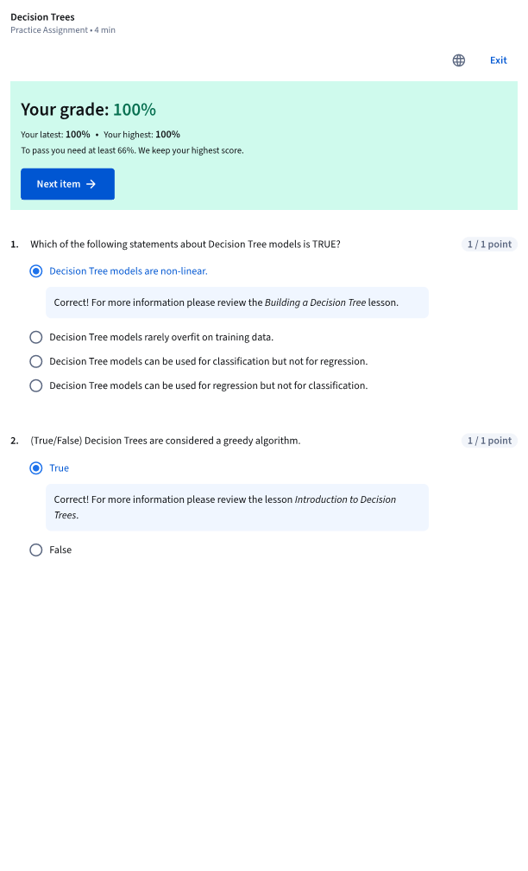

# Module4_ Decision Trees Labs

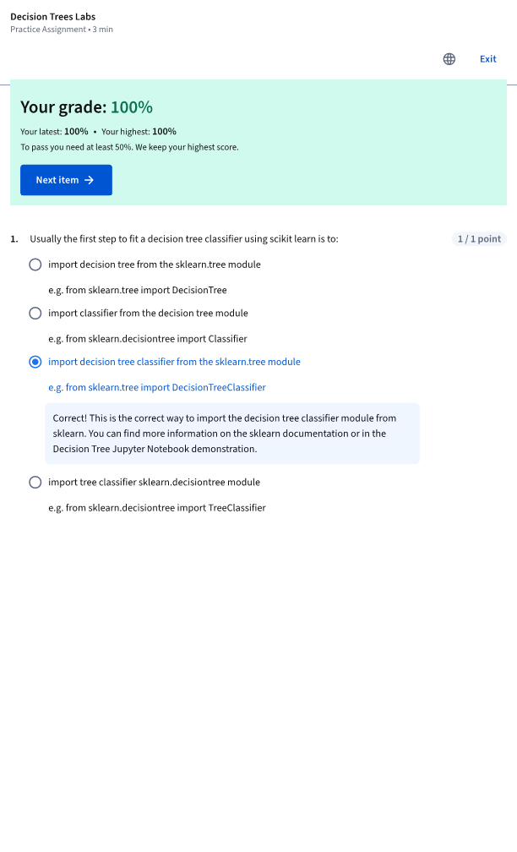

# Module4_ Decision Trees

